Internet of Things

# Requirements & Initial Design

# Requirements

1. This object should be as compact as a normal desk lamp so it will not take up too much space on desks.
2. The lamp needs to be able to detect the time of day and adjust the temperature accordingly.
3. Display information in the LCD.
4. Have a focus mode to help with productivity. (For final design)
5. It needs to look pleasing on a desk. (For final design)
6. Needs to read the light level in the room.

# Initial Design

Sketches of Proposed device



The objective of our project is to make a lamp that can read the light level in your room. The temperature of the light should change depending on the light level in the room to reduce the amount of eye strain. We also intend to implement an LCD display into the lamp to display items like the time. We also want to track the amount of time you have spent on your computer so it can tell you when to take breaks.

# Proposed Code Design

The most basics functions we need this device to be able are:

* Check the time.
* Change the brightness or temperature of a LED, or a RGB LED.

# Checking the Time

To code the clock section of the project we decided to research some example code online that could help us. We found code that would help us. However, we had to modify it as it would display the output inside the Arduino IDE instead of on our LCD.

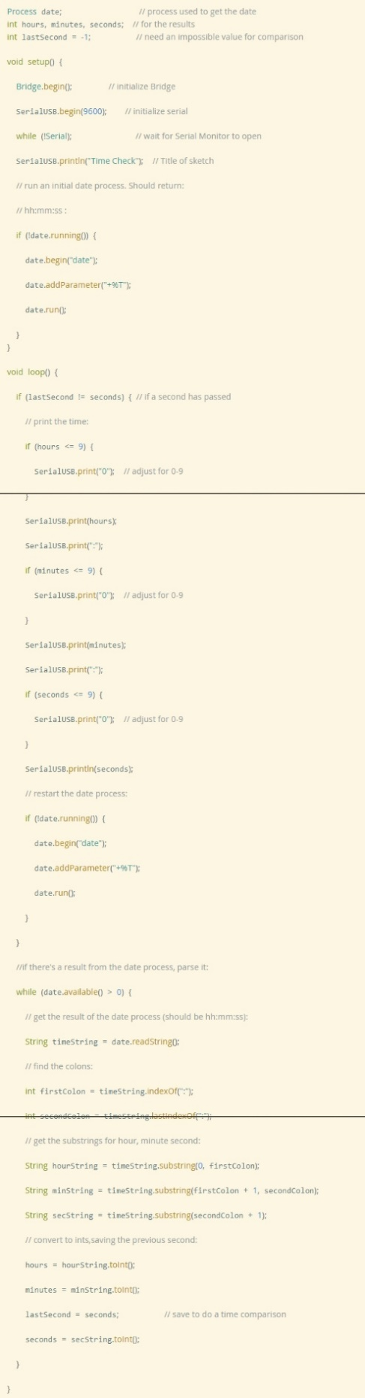

# Modified Code

We modified the code so that it would work with our LCD display.

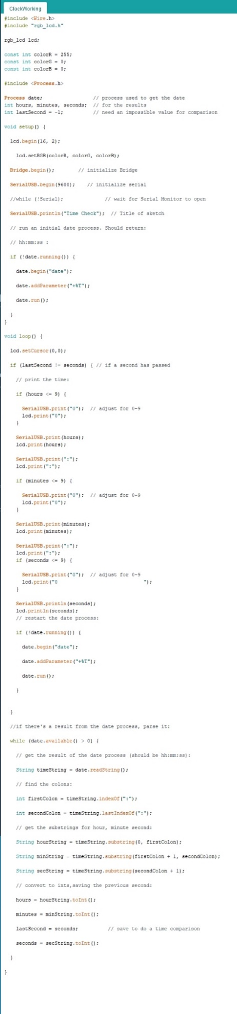

# Controlling the LED

We found this code online for controlling a LED with the light sensor in the grove kit. I modified it to work with two LEDs but unfortunately, I couldn’t get it to work with more than one LED.

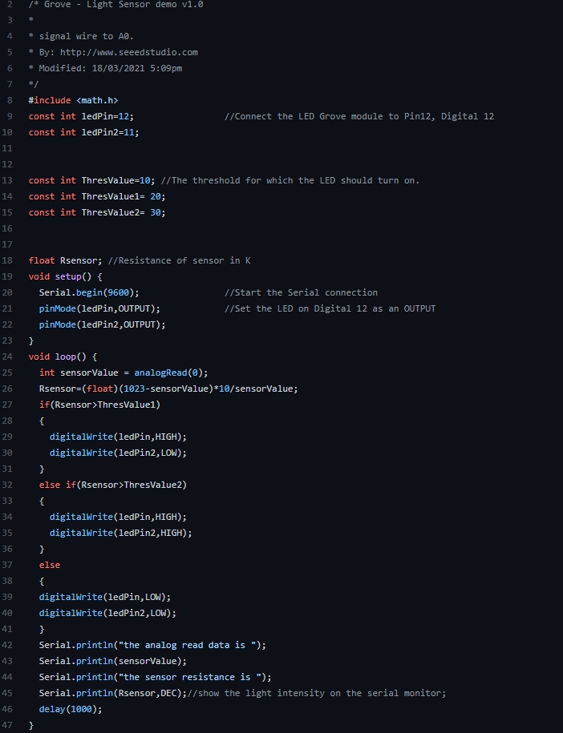

# Final Code

For the final code I just combined the time reading code and the LED code into one project.

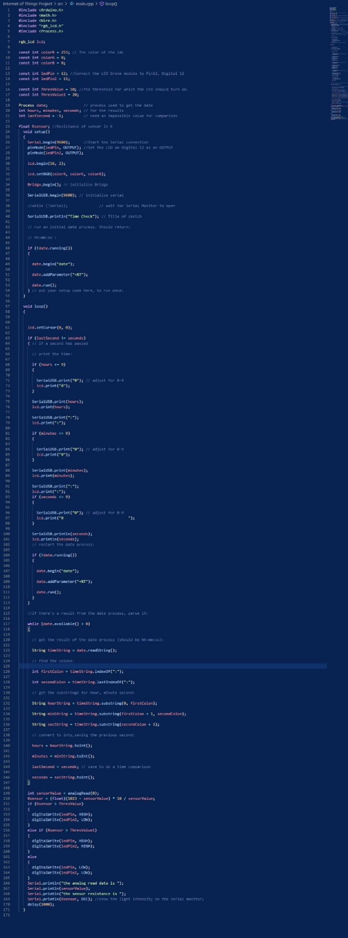

# Proposed hardware setup

The hardware we will use for this project are:

* Base shield
* LCD RGB Backlight
* LED x2
* Light Sensor
* Wires

